Assignment 3

|  |  |
| --- | --- |
| Assignment Date | 31 October 2022 |
| Student Name | Deepthi op |
| Student Roll Number | 311019104017 |
| Maximum Marks | 2 Marks |

# Question 1:

Create a bucket in IBM object storage.

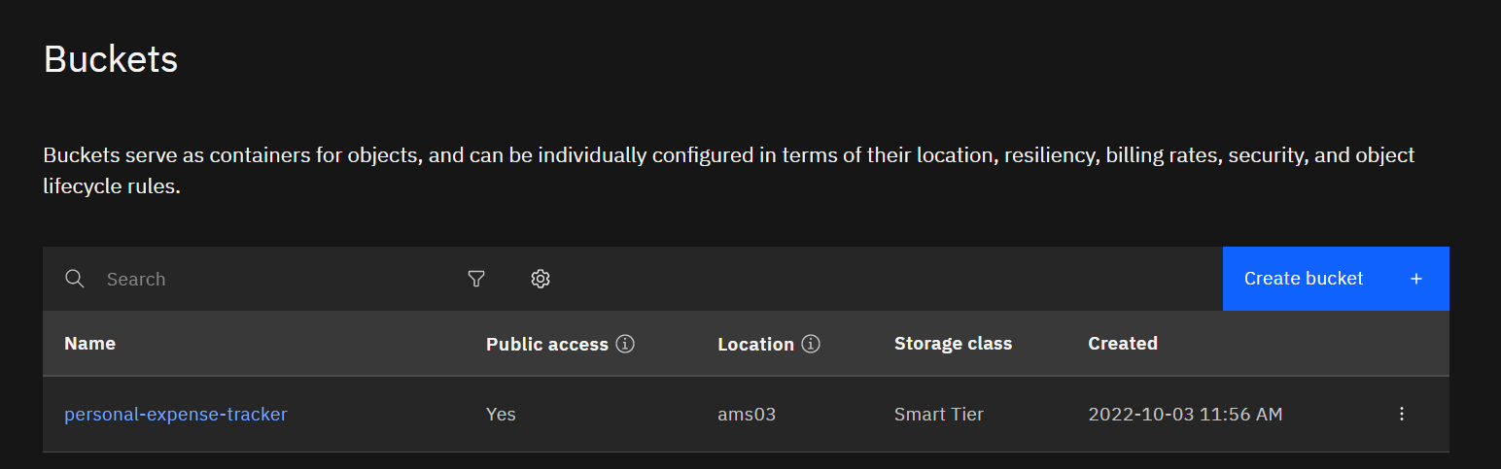

2022-10-31

# Question 2:

Upload any5imagesto IBM objectstorage and make itpublic. Write HTML code to displaying all the 5 images

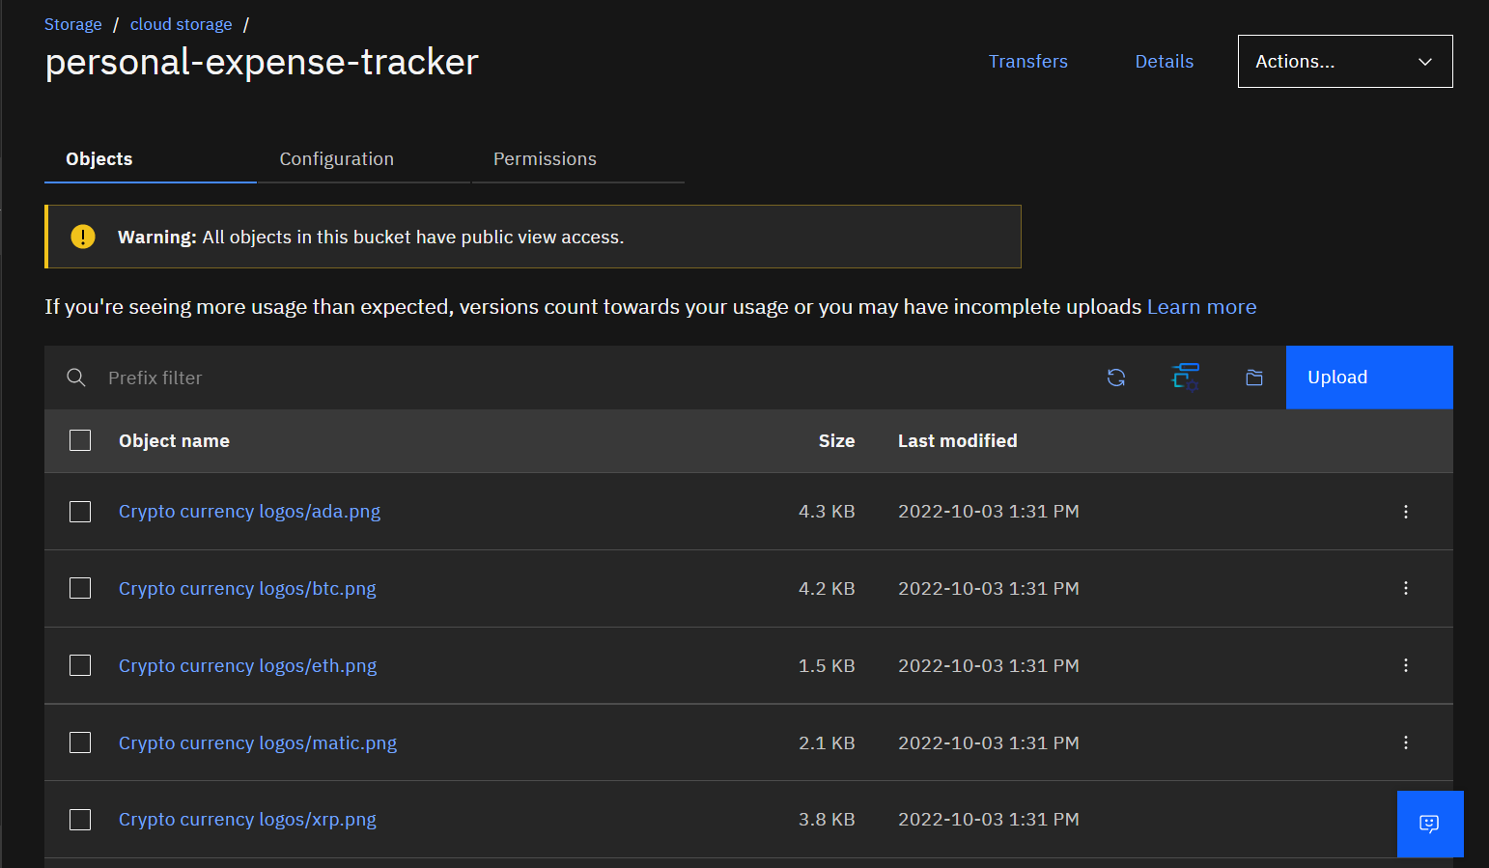

2022-10-31

2022-10-31

2022-10-31

2022-10-31

2022-10-31

HTML code for displaying images in cloud

<!DOCTYPE html>

<html lang="en" dir="ltr">

<head>

<meta charset="utf-8">

<title>Crypto currencies</title>

</head>

<body>

<h1>Popular Cryptocurrencies</<h1>

<h2>1 Bitcoin BTC </h2>

<img

src="https://personal-expense-tracker.s3.ams03.cloud-object-storage.appdomain. cloud/Crypto%20currency%20logos/btc.png" alt="Bitcoin">

<h2>2 Ethereum ETH</h2>

<img

src="https://personal-expense-tracker.s3.ams03.cloud-object-storage.appdomain. cloud/Crypto%20currency%20logos/eth.png" alt="Ethereum">

<h2>3 Polygon MATIC</h2>

<img

src="https://personal-expense-tracker.s3.ams03.cloud-object-storage.appdomain. cloud/Crypto%20currency%20logos/matic.png" alt="Polygon">

<h2>4 Ripple XRP</h2>

<img

src="https://personal-expense-tracker.s3.ams03.cloud-object-storage.appdomain. cloud/Crypto%20currency%20logos/xrp.png" alt="XRP">

<h2>5 Cardano ADA</h2>

<img

src="https://personal-expense-tracker.s3.ams03.cloud-object-storage.appdomain. cloud/Crypto%20currency%20logos/ada.png" alt="Cardano">

</body>

</html>

HTML Output for displaying images from IBM cloud storage:

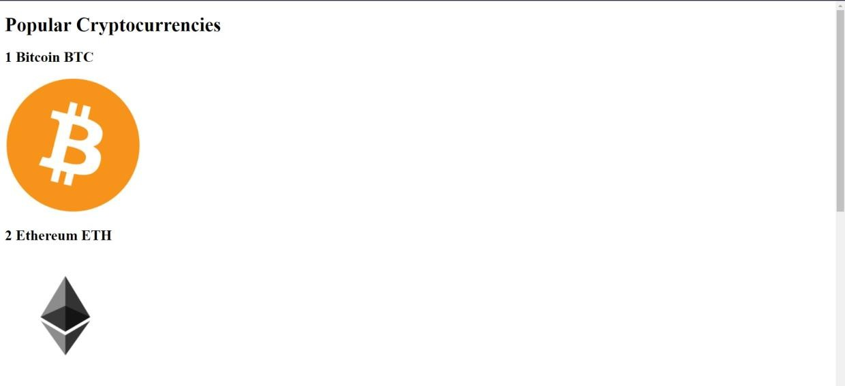

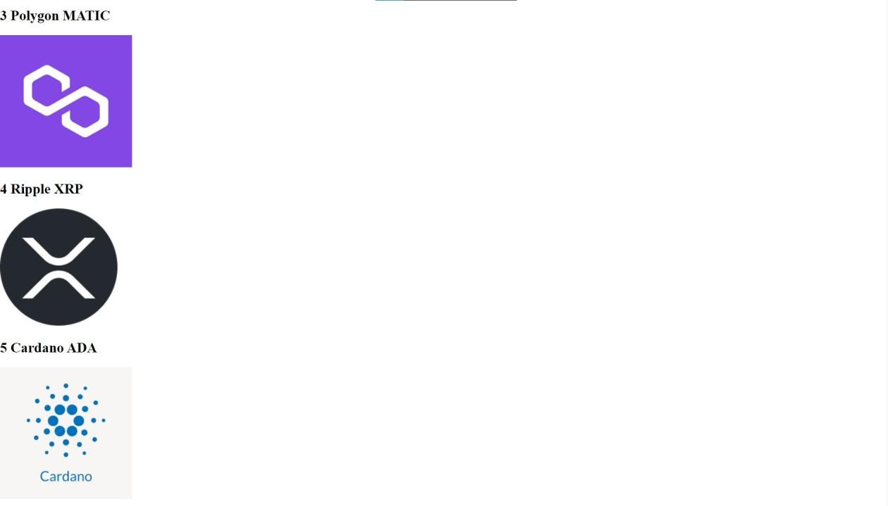

# Question 3:

Upload a CSS page to the object storage and use the same page in your HTML code.

HTML code with CSS ﬁle present in IBM cloud storage:

<html>

<head>

<title>Home page</title>

<link rel="stylesheet"

href="https://personal-expense-tracker.s3.ams03.cloud-object-storage.appdomain

.cloud/style.css">

</head>

<body>

<h1>Hi there</h1>

<p>Here is the CSS file present in IBM cloud storage <a href="https://personal-expense-tracker.s3.ams03.cloud-object-storage.appdomain

.cloud/style.css">Click here</a></p>

</body>

</html>

HTML code output:

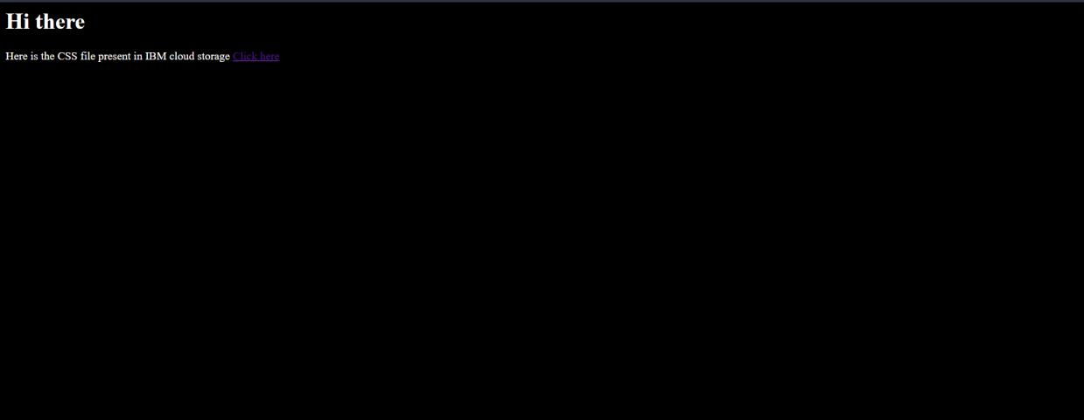

CSS ﬁle in Cloud object storage

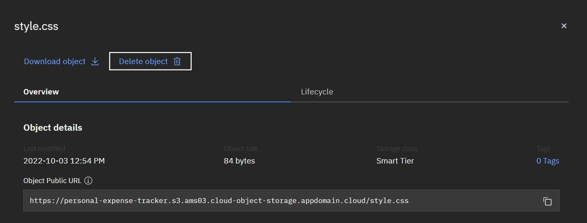

2022-10-31

# Question 4:

Design a chatbot using IBM Watson assistant for hospital. Ex: User comes with query to know the branches for that hospital in your city. Submit the web URL of that chat bot as a assignment.

# Web URL of chat box:

[https:*/* web-chat.global.assistant.watson.appdomain.cloud/preview.html?ba](https://web-chat.global.assistant.watson.appdomain.cloud/preview.html?backgroundImageURL=https%3A%2F%2Fjp-tok.assistant.watson.cloud.ibm.com%2Fpublic%2Fimages%2Fupx-f3a1f015-5572-4204-96b6-7c25f885ddc6%3A%3A156bcb72-665e-46b3-872e-a17217657433&integrationID=d2b53d34-6e0e-4d81-b157-ae1023cd641a&region=jp-tok&serviceInstanceID=f3a1f015-5572-4204-96b6-7c25f885ddc6) [ckgroundImageURL=https%3A%2F%2Fjp-tok.assistant.watson.cloud.ibm.co](https://web-chat.global.assistant.watson.appdomain.cloud/preview.html?backgroundImageURL=https%3A%2F%2Fjp-tok.assistant.watson.cloud.ibm.com%2Fpublic%2Fimages%2Fupx-f3a1f015-5572-4204-96b6-7c25f885ddc6%3A%3A156bcb72-665e-46b3-872e-a17217657433&integrationID=d2b53d34-6e0e-4d81-b157-ae1023cd641a&region=jp-tok&serviceInstanceID=f3a1f015-5572-4204-96b6-7c25f885ddc6) [m%2Fpublic%2Fimages%2Fupx-f3a1f015-5572-4204-96b6-7c25f885ddc6](https://web-chat.global.assistant.watson.appdomain.cloud/preview.html?backgroundImageURL=https%3A%2F%2Fjp-tok.assistant.watson.cloud.ibm.com%2Fpublic%2Fimages%2Fupx-f3a1f015-5572-4204-96b6-7c25f885ddc6%3A%3A156bcb72-665e-46b3-872e-a17217657433&integrationID=d2b53d34-6e0e-4d81-b157-ae1023cd641a&region=jp-tok&serviceInstanceID=f3a1f015-5572-4204-96b6-7c25f885ddc6)

[%3A%3A156bcb72-665e-46b3-872e-a17217657433&integrationID=d2b5](https://web-chat.global.assistant.watson.appdomain.cloud/preview.html?backgroundImageURL=https%3A%2F%2Fjp-tok.assistant.watson.cloud.ibm.com%2Fpublic%2Fimages%2Fupx-f3a1f015-5572-4204-96b6-7c25f885ddc6%3A%3A156bcb72-665e-46b3-872e-a17217657433&integrationID=d2b53d34-6e0e-4d81-b157-ae1023cd641a&region=jp-tok&serviceInstanceID=f3a1f015-5572-4204-96b6-7c25f885ddc6) [3d34-6e0e-4d81-b157-ae1023cd641a&region=jp-tok&serviceInstanceID=f](https://web-chat.global.assistant.watson.appdomain.cloud/preview.html?backgroundImageURL=https%3A%2F%2Fjp-tok.assistant.watson.cloud.ibm.com%2Fpublic%2Fimages%2Fupx-f3a1f015-5572-4204-96b6-7c25f885ddc6%3A%3A156bcb72-665e-46b3-872e-a17217657433&integrationID=d2b53d34-6e0e-4d81-b157-ae1023cd641a&region=jp-tok&serviceInstanceID=f3a1f015-5572-4204-96b6-7c25f885ddc6) [3a1f015-5572-4204-96b6-7c25f885ddc6](https://web-chat.global.assistant.watson.appdomain.cloud/preview.html?backgroundImageURL=https%3A%2F%2Fjp-tok.assistant.watson.cloud.ibm.com%2Fpublic%2Fimages%2Fupx-f3a1f015-5572-4204-96b6-7c25f885ddc6%3A%3A156bcb72-665e-46b3-872e-a17217657433&integrationID=d2b53d34-6e0e-4d81-b157-ae1023cd641a&region=jp-tok&serviceInstanceID=f3a1f015-5572-4204-96b6-7c25f885ddc6)

Watso a Assistant —

Welcome, how can I assist you?

appointment booking

please select the preferred branch location

Delhi Numbai Chennai

ftotkata

Please select the preferred timing for appointment.

9:30 am 11:30 am 2:3O pm

5:00 pm

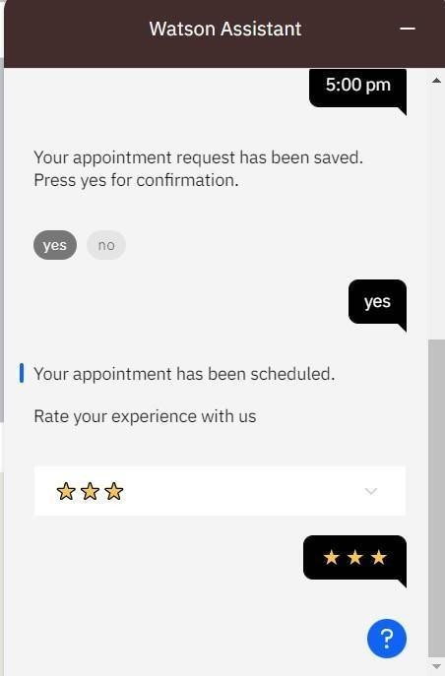

# Question 5:

Create Watson assistant service with 10 steps and use 3 conditions in it. Load that script in HTML page.

Script in HTML page:

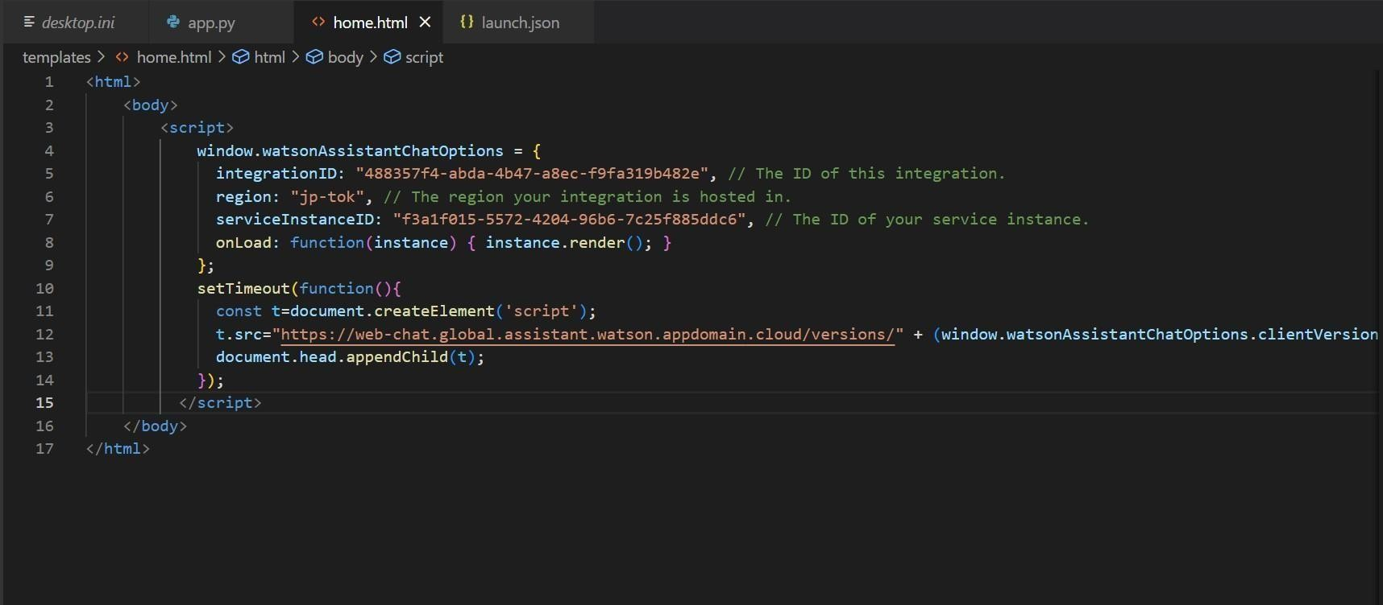

Food-ordering bot:

## Welcome, how clan I assist you?

order food

Select the food item









## For delivery we yvill need a few pieces of information. Let me guide you through this process!

#### First, please provide your first name.



Thanks! Now, enter your last name.

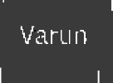

#### Awesome. I’llatso need an email address associated with your new account. We will send you the delivery details to your email

Which email address would you like to use?





## Enter the delivery location

14 th Street Manhattan newtown

We need your i›hone nunbcr to contact you. Would you like to do so?

Yes, I'd like to add a phone numbers

Yes, I'll liketoaddai›hone number.

O kay, please ente r your phone number below.

l234o6789

Please enter a valid who ne nrim bei.



## Thands! Docs the followingng information look correct? If so, I Will proceed toplacing your order

* Name: Doobie
* Email Address: [doobie@gmail.com](mailto:doobie@gmail.com)
* Phone Number: 6482973043
* Delivery Location: 14th Street Manhattan



* Email [Address:doobie@gmail.com](mailto:doobie@gmail.com) “
* Phone Number: 6482973043

### Delivery Location: 14th Street Manhattan

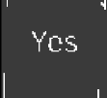

#### Your order will delivered within 30 mins ! You will receive an email conformation shortly.

WeSCO 0!